

Health Care Management System

Submitted in partial fulfillment of the requirements

of the degree of

Bachelor of Engineering

by

Sai Bhatkar Roll No. 12

Yash Chande Roll No. 15

Ashutosh Bagal Roll No. 8

Darpan Chaudhari Roll No. 16

Supervisor:

Prof. Anushree Patkar.



Department of Information Technology

Atharva College of Engineering

Year: 2020-21



**ATHARVA COLLEGE OF ENGINEERING**

**MALAD (W), MUMBAI 400 095**

**YEAR: 2020-2021**

CERTIFICATE

*This is to certify that*

**Sai Bhatkar Roll No. 12**

**Yash Chande Roll No. 15**

**Ashutosh Bagal Roll No. 8**

**Darpan Chaudhari Roll No. 16**

*have submitted the Mini Project report for the requirements of the Bachelor of Engineering in Information Technology satisfactorily*

on

**“Health Care Management System”**

*As prescribed by the* ***University of Mumbai*** *Under the guidance of*

**PROJECT GUIDE H.O.D. PRINCIPAL**

**INTERNAL EXAMINER COLLEGE SEAL EXTERNAL EXAMINER**

Approval for S. E. Mini Project Report

This project report entitled (***Health Care Management System***) by (***Author Name***) is approved for the degree of ***Bachelor of Engineering in Information Technology.***

**Examiners:**

* 1. -----------------------------------

(Internal Examiner Name & Sign)

* 1. -----------------------------------

(External Examiner Name & Sign)

Date: 05/11/2020

Place: Mumbai

**Contents**

**Abstract**

**1.** **Introduction**

**1.1** **Introduction**

**1.2** **Motivation**

**1.3 Problem Statement(2 to 3 lines)**

**1.4 Objectives(1 or 2 lines)**

**2.** **Literature Survey**

**2.1 Survey of Existing system**

**2.2 Limitation Existing system or research gap**

**2.3 Mini Project contribution**

**3.** **Proposed System**

**3.1 Architecture/Framework**

**3.2 Algorithm and Process Design**

**3.3 Software Requirement Specification**

**3.4 Implementation Code(write classes as heading)**

**3.5**  **Output Screenshots(with title of each output)**

**4.**  **Conclusion(5 to 6 lines)**

**5. Future work**

**References (include IEEE Paper names. No Wikipedia.com, google.com)**

**Acknowledgement**

**Introduction**

* **Motivation**

Today due to pandemic people are afraid of going hospital/clinic. So this application would reduce their work little bit.

* **Problem Statement**

This management system focuses on health care system in a hospital. Due to current pandemic people are finding a way for their health issues over internet. But some problem needs doctor’s consultation and medical facilities. So this system would help employees of hospital to manage the large data of patients.

In this application Admin will handle all of the process. A login page will take you to the main window of application where admin can create new user and also check details of existing user. He/she can take details from patient and enter it into the database which is MYSQL used here. Also, New entries of doctor and booking of rooms can be done through this.

This will help the Admin a lot by reducing their work. Also he/she can give the access to other employees if necessary. The data will be confidential which is a very important aspect.

* **Objectives**
* To save time of people.
* Promote social distancing.
* This will help to handle large data.
* Manual work will be less.

**Literature Survey**

* **Survey of Existing system**

Now-a-days people are more likely to use web based applications for manual working things. Organization appoints people for it. In existing system manual work is more.

* **Limitation Existing system or research gap**

Actually the limitations it is not used mostly or often. I t should be for every field not only in Tech field.

* **Mini Project contribution**

Our mini project is basically using this technique in medical line to contribute a little help by reducing their manual work and to make the work more efficient. Also this will promote social distancing.

**Proposed System**

* **Architecture/Framework**

Java language, Java AWT, Java Swing and Java Fx.

* **Software Requirement Specification**

PC i3 processor or higher, web browser like chrome, IDE like Vscode, Eclipse, Netbeans, JDK 1.8 or higher, Windows or Linux desktop OS.

* **Algorithm and Process Design**

Shown in next slide

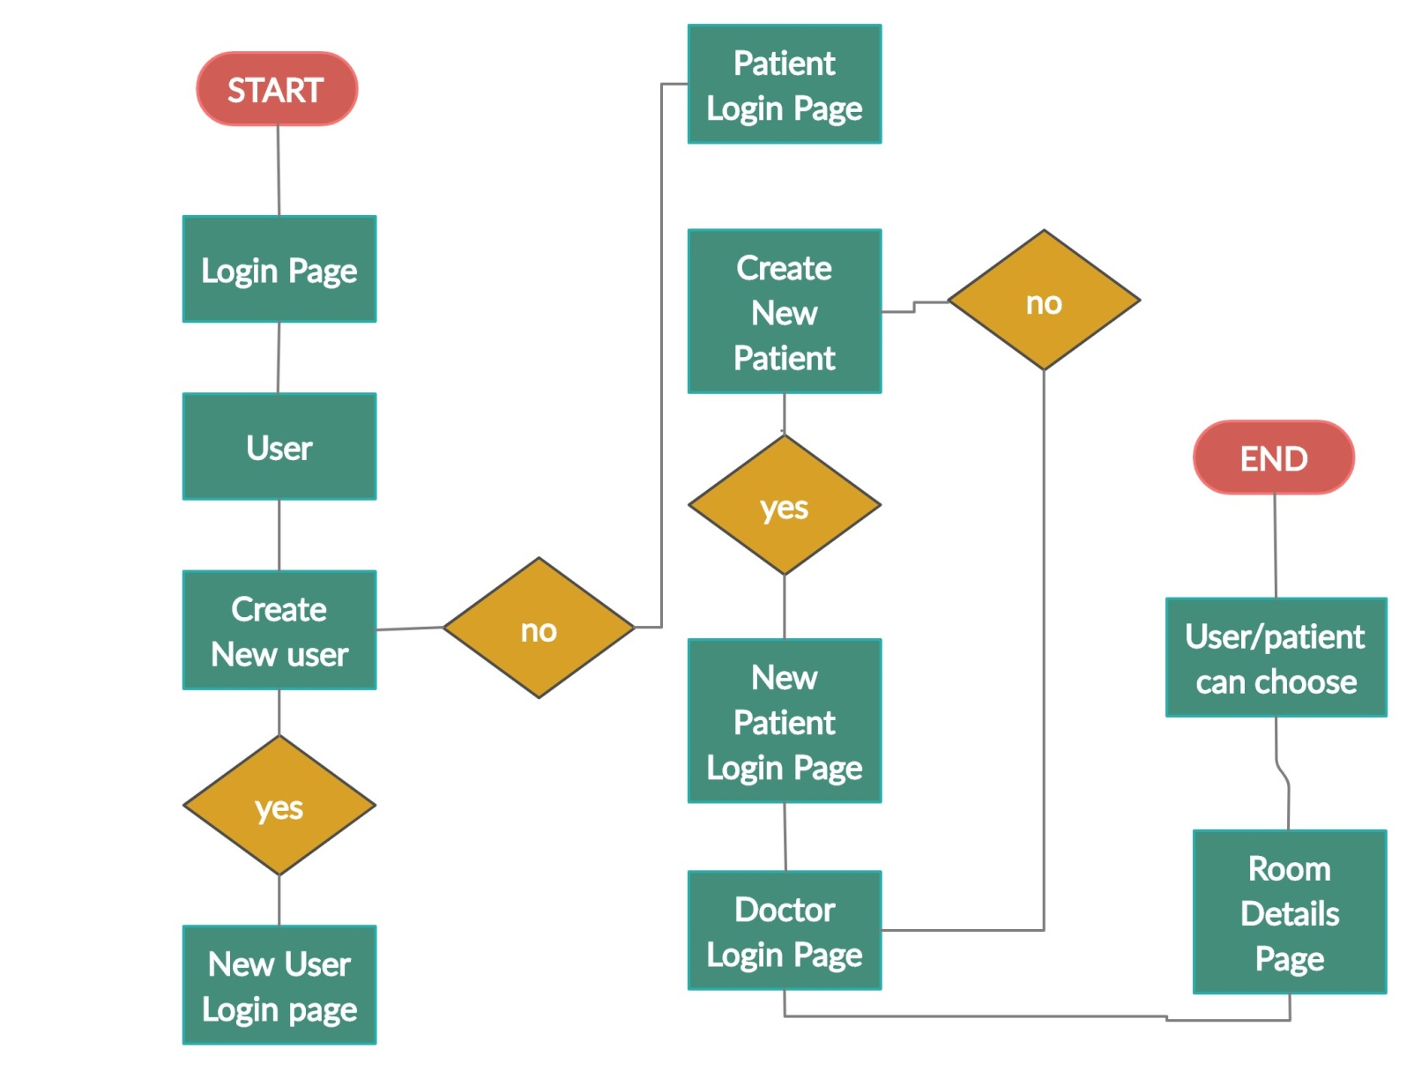

* **Output**

**Outputs are as follows**

**Login page**

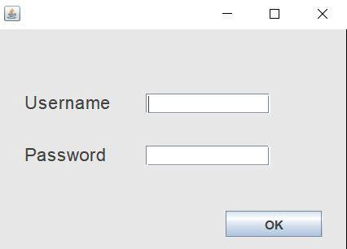

**Main Window**

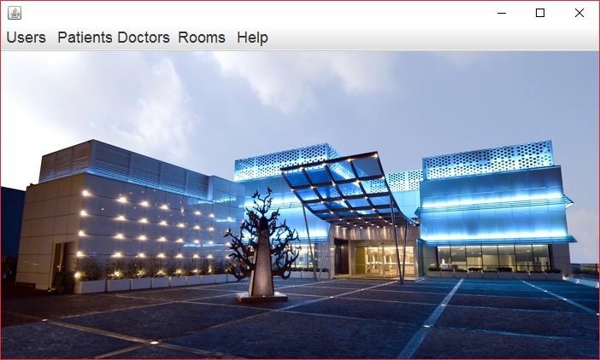

**Patient Detail Page**

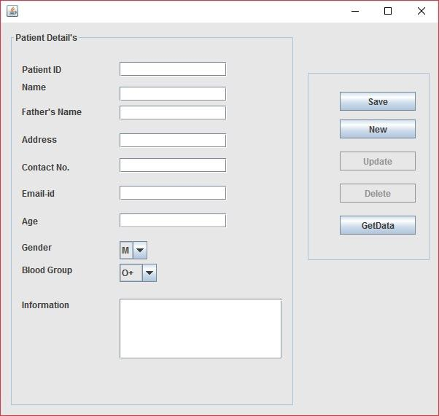

**Patient Detail Sample**

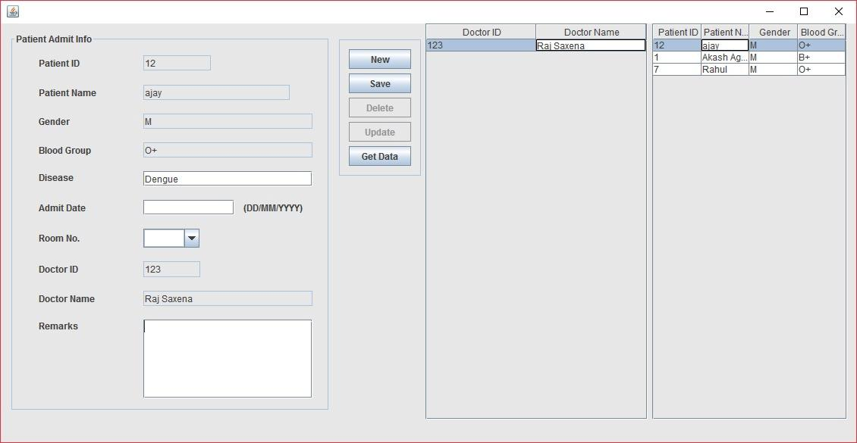

**Service Page**

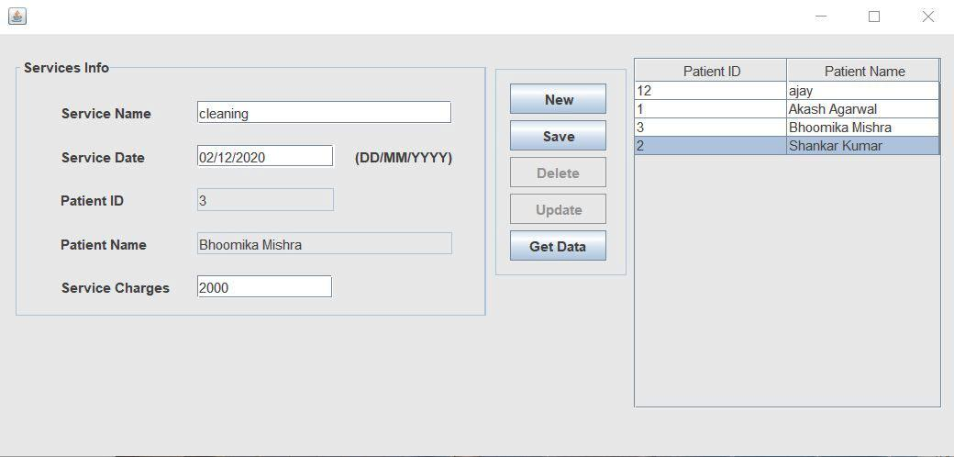

**Doctor Detail Page**

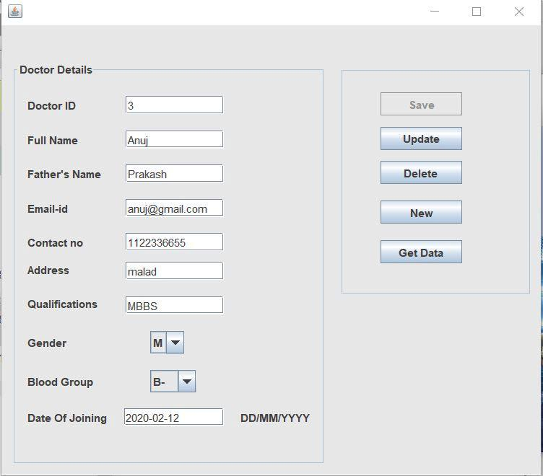

**Doctor Database**

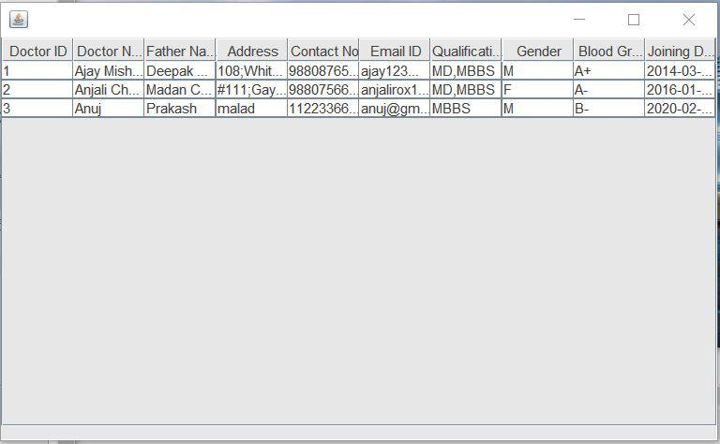

**Room Detail Page**

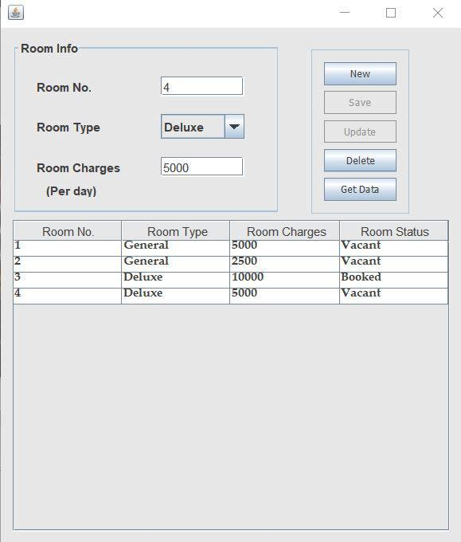

**Working**

* Firstly, when program runs login page appears, we just have to put username and password if you are an existing user.
* In user’s section we have options of New user, Existing User and details which will show the information about the users (username & password) which will get stored in database.
* Also user has options to update his/her information and data gets updated in database.
* In patient’s section we can register new patient details and also check available services.
* In services we can check services provided by hospital/organization and user’s has the option to choose it.
* Only existing user’s/patients can avail the services.
* In Doctor’s section entry of new doctors can be made by entering their information.

**Conclusion**

* Thus by using JAVA we created an application for “Health Care Management System”.
* It will help our medical management system and make it more efficient for people.
* The GUI present will make the work easier and also operate on Windows OS.

**Future Work**

* If in future pandemic like COVID-19 occurs this application will be very useful for people.
* This can be used not only in hospitals but also in various domains respectively.
* Also it can be modified or create a new version in future with more added features and easy handling for people.
* It can be used in Universities, like externals can put their schedule into the database and can manage the viva’s, practical examination etc. effectively.

**References**

**IEEE standard**

**Book,**

[1]. E. Balguruswamy, “Programming with Java A primer”, Fifth Edition, Tata McGraw Hill Publications.

**References**

[2]. Yashwant Kanetkar, “Let Us Java”, 4th Edition, BPB Publications.

**\*NOTE:**

* **Last date to submit the rough synopsis with Guide and Co-Guide sign on/before 05/11/2020 and Final synopsis to be submitted with project coordinator sign on 07/11/2020.**
* **Kindly follow the above sequence while preparing synopsis otherwise final submission will not be expected.**